Design and Use of a Program for Salary Prediction Utilizing Tree Model
Introduction:
For instance, what is ‘salary’? It’s a fixed amount payable at regular intervals, it can be weekly or monthly payments straight to an employee’s bank account.
Wages are hourly or daily payments for work done during the working day.
The main difference between salary and hourly wage is that salaries are fixed upon payment agreed to by both the employer and employee. Wages, on the other hand, may vary depending on hours worked and performance.
The terms ‘salary’ and ‘wages’ are often used interchangeably. The fact is, these two terms hold different meanings.

Benefits of salaried pay
- Consistency: Your employees are guaranteed a certain amount every week or month excluding bonuses. This makes financial planning easier as they’d know how much is coming in and going out in a salaried job.
- Additional perks: Salaried employees are entitled to a number of paid days off every year. The number of days would be pre-agreed with your employer. It is also possible to agree on flexible working hours. So employees can come in to work an hour or two earlier to leave an hour or two later.
- Higher wages: Salary workers generally have more responsibilities compared to their waged counterpart. Salaried workers might have to work more than the standard work-hour week to catch up with deadlines. Compensation for these responsibilities is reflected in their salary.
Disadvantages of salaried pay
- Overtime: One of the main disadvantages of salaried pay is working overtime. Although salaried employees are entitled to overtime, tracking overtime can be a bit of a challenge. An hourly worker would work overtime and simply charges for the hours they worked.
- Pay cuts: Companies going through tough financial periods slash expenses by cutting pay. Although waged employees are more likely to get their hours cut, it wouldn’t affect their hourly rate as they only get paid for the hours they work. While salary workers might need to work more hours with no extra pay.
- Public holiday pay: Like overtime pay, waged workers are often paid more to work on public holidays like Christmas or Easter. Depending on the nature of your business and contract, salaried workers might have to work over holiday periods without extra pay.

Planning and Design:
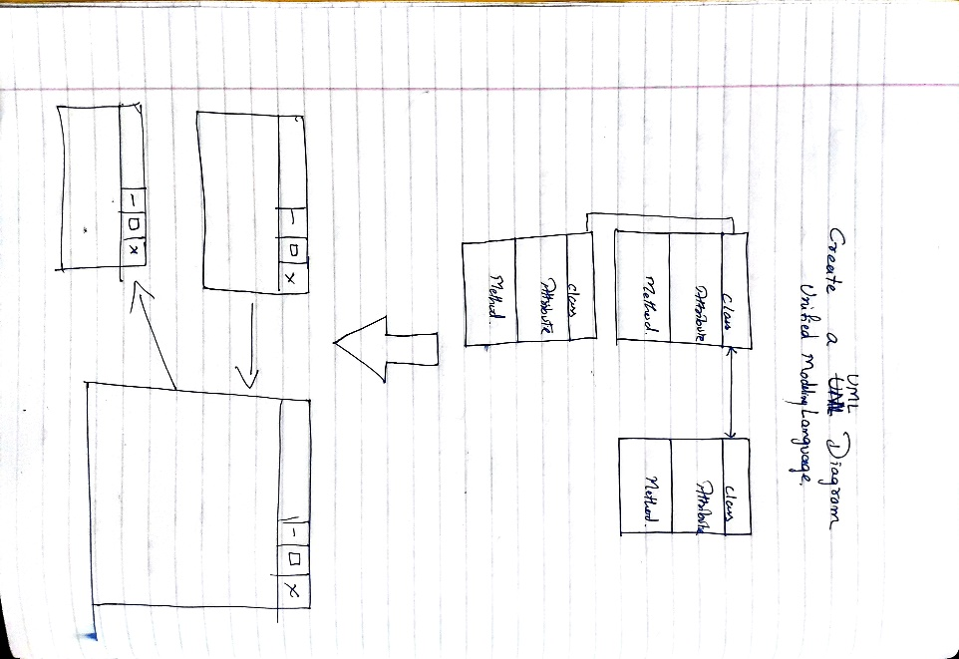
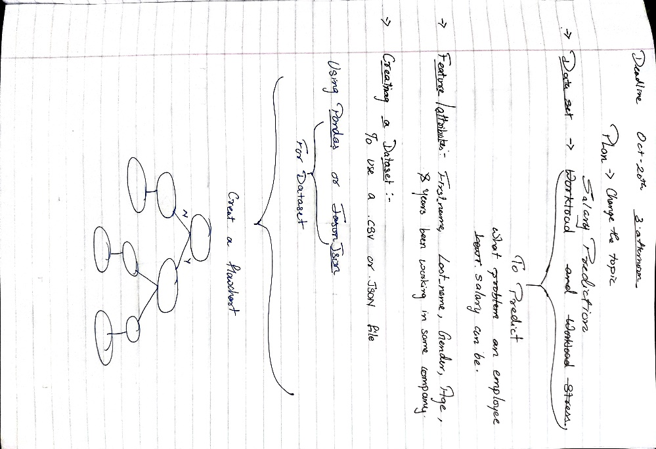

In the project , there is a use of dataset to predict the salary for your job. For a time the work start and wages comes into existence, And it will continue until there is work and the world has changed to something worth to say it is place of future.

For doing something like prediction of salary this project need the prequiped dataset and a dataset from Kaggle. The datset is new and uploaded in 2023 and named Salary_Prediction(Alan Itzee Cano, 2023)
  - There are features and attribute depending on what data the program is trying to analyze, the feature include in dataset include in dataset can vary widely.
  - To create a dataset, there are several ways but in this project pandas or json will be needed.
  - Flowchart will help in creating an application from start to the end with condition in between.
  - UML Diagram will help in creating a class, attribute an dmethod to use while creating a program while creating a UML Diagram what is the relation between one class to other class this will help in creating a program whether it has inheritance or not.
Fourth Page
Third Page Page
Second Page
First Page
Inheritance
Inheritance
Inheritance
Username
Password
Welcome Page
Main GUI with user name of it
Page will display output

  - And the last is GUI which will represent the actual graphical display of the program and its working. The Graphical User Interface is totally prepared based on the program.

1. Introduction
2. Understanding the importance of salary prediction
3. Introducing Kaggle's Jobs Dataset from Glassdoor
4. Exploring the variables used for salary prediction
5. Building a predictive model using the dataset
6. Evaluating the accuracy of the model
7. Applying the predictions to real-world scenarios
8. The limitations of salary prediction models
9. Conclusion: Leveraging data to make informed salary decisions

